For office use only: IMV001
Reviewed by: RC/TC/TS
Date: 05/22

Volunteer Role Description

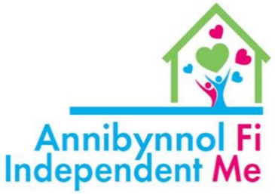
Location of position: Outreach/within the Community
Responsible to: Volunteer Co-ordinator and Marketing and administration officer
Time commitment: Flexible/Hours to be agreed

Purpose/Summary of role:

To provide companionship support to anyone living in Conwy in the prevention of loneliness and isolation. There are a number of reasons people in the local community become isolated by having little or no contact with people and overtime this can have a detrimental effect on a person’s health and wellbeing. Having a regular visitor to get out and about, chat with and just having someone to listen can make a real difference.

How it Works:

Our Independent Me Volunteers are matched with a person, taking into account their needs, interests and hobbies of the individual. The Independent Me Volunteer will then have an initial meeting with the person they may be supporting. The whole process is supported by the Volunteer Coordinator and Independent Me Marketing and administration officer, who will be there to help and support both you as a volunteer and the person you will be matched with every step of the way.
Hours can be flexible, but this is also dependent on the needs of the person you will be matched with, which will be based on the times, day and hours agreed during your initial visit with the person you will be providing companionship support for.
We’re looking for people who have the following Skills & Qualities:

- Good listening skills | - Patience, empathy and understanding
- A clear sense of personal boundaries and confidentiality | - Flexible, reliable and punctual
- Ability to provide non-judgemental support | - Engage with training and development
- Ability to keep records of visits made | - Record any further assistance as required

What you can expect in return:

- Induction to the organisation
- Participation in the Volunteer Rewards Scheme
- Full training on all aspects of the role

Each volunteer will complete the Independent Me Training Programme (online e-learning and accredited training) which will consist of:
- Safeguarding Children & Vulnerable Adults | - GDPR
- Having Difficult Conversations | - Confidentiality
- Professional Boundaries | - Mental Health First Aid
- First Aid | - Manual Handling

Reimbursement of Expenses:
Out of pocket expenses will be reimbursed as follows:
- Mileage costs @ 40p per mile from home to place of volunteering
- Public transport costs reimbursed on receipt of valid ticket
- Up to £7.50 per day to pay for things like coffee’s etc when they are taking a person out carrying out befriending activities (receipts will need to be provided to claim this expense)

How to Apply:
- Email tish.calveley@creatingenterprise.org.uk or telephone 01492 588 980
- Express an interest in which role you are interested in
- Speak to Volunteer Co-Ordinator

Line Manager: Date:

