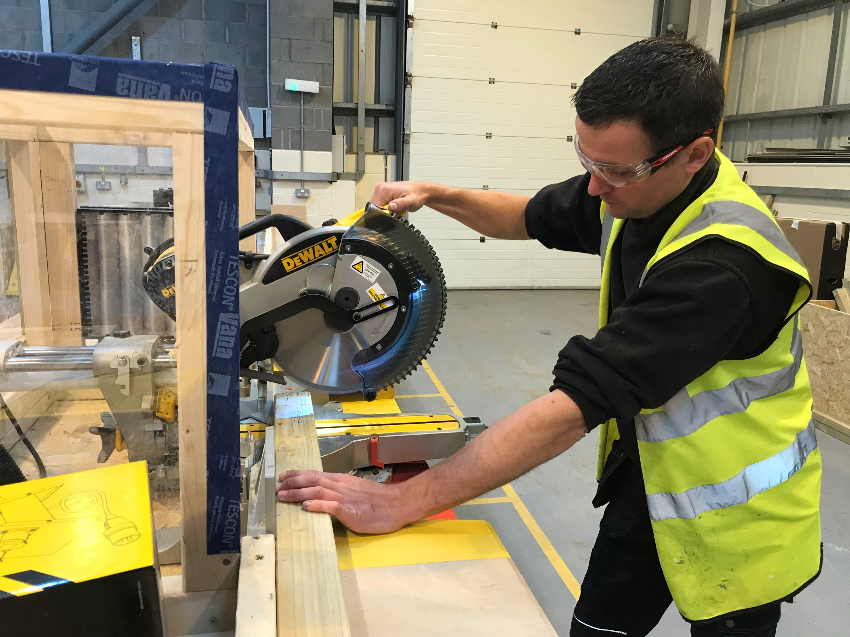

**Modern Apprentice Joinery**



**Creating Enterprise is a Community Interest company and a subsidiary of Cartrefi Conwy**



* **Modern Apprenticeship in Joinery. Study towards NVQ Level 2 in Joinery whilst assisting in the full range of Joinery Works (under supervision).**

**To apply:**

**www.creatingenterprise.org.uk**

**vacancies@creatingenterprise.org.uk**

**01745 335684**

* **Salary: National Minimum Wages/Living Wage**
* **Hours of work: 42 hours per week**
* **Contract: 2 Year FTC**
* **Location: Mobile**



**Closing date:**

**17/07/2020**

**THIS VACANCY IS ONLY OPEN TO   
CARTREFI CONWY TENTS.**