

JOB DESCRIPTION

- JOB DETAILS
JOB TITLE | Cleaner/Relief Caretaker
REPORTS TO | Business Co-ordinator and on site supervision Charlotte Bennett
DIRECT REPORTS | None
TEAM | Creating Enterprise
LOCATION | Morfa Gele, Abergele
SALARY DETAILS | National Minimum / Living Wage

- PURPOSE
To clean the office premises, ensuring that it is presented at all times to the highest standard of cleanliness and support the Caretaker in ensuring the security of the building at all times.

- DIMENSIONS Scale & Diversity
The office accommodates approximately 120 colleagues with scope for the Resource Centre to be made available for use by the public in the future.

- MAIN ACCOUNTABILITIES
General Cleaning Duties:
- To ensure the highest standards of cleanliness are maintained at the building;
- To undertake cleaning activities such as sweeping/mopping stairs or floor areas, hoovering, polishing windows and/or skirting and replenish toilet paper, hand towels and soap etc.
- To undertake cleaning in toilet areas, this includes mopping floors, cleaning sinks, toilets and wiping walls etc.
- To undertake cleaning, as required, as a result of spillages and other accidents to ensure that the premises are a clean, safe, healthy and comfortable place for colleagues and visitors.
- To remove recyclable materials (cardboard boxes, etc.) and dispose of safely in the Bin Store ready for collection by the Local Authority;
- To remove cups, plates and any remaining buffet at the end of the day after meetings have taken place;
- To ensure cutlery and crockery is washed and put away;
- To report any defects to the building, furniture, fittings and equipment to your line manager;
- To water and maintain any flora and fauna within the Office building;
- To inform the Caretaker when stocks of necessary equipment and supplies relating to office cleaning, kitchen and housekeeping, such as toilet rolls, hand wash, washing up liquid, milk etc. are low.
Inspections and Health & Safety
- To ensure all fire escape routes are kept clear of hazards;
- To comply with safe working practices, health and safety guidelines for example, COSHH, use of PPE, Fire Safety and safe manual handling; ensuring that the safety of Cartrefi Conwy colleagues and the wider public is not negatively affected by the activities of Creating Enterprise.
Other:
- To attend meetings, training courses and study days as directed by your line manager.
- To deputise for the Caretaker in the event of annual leave, sickness or other absence etc – please refer to the Caretaker job description for further details. This includes key holding responsibility for the building and ensuring the building is secure.
- To undertake such other duties appropriate to the post as may from time to time be required to ensure the smooth and efficient running of the building.

- CORPORATE ACCOUNTABILITIES
To actively support the overall delivery of Creating Enterprise’s objectives to provide an excellent, innovative and truly customer focused service.
As a representative of Creating Enterprise, to, promote and maintain a positive attitude and image at all times.
To positively promote Creating Enterprise’s values; constructively challenging traditional ways of working, contrary behaviour or comments.
To ensure feedback is actively sought in order to inform service improvement for customers and develop more efficient and effective ways of working.
To ensure compliance with Creating Enterprise’s Standing Orders, policies and procedures.
To support the development, review and implementation of policies and procedures, in particular of:
- Health, safety and welfare initiatives
- Creating Enterprises’ principles on Equality and Diversity
- Risk management initiatives
- Performance management practices
To utilise ICT technology and systems effectively by developing appropriate skills, adopting efficient business processes, and maintaining data securely and accurately.
To work collaboratively where required.

- WORK CONTEXT (environment, type of equipment)
This role will be carried out in Cartrefi Conwy’s Head Office in Abergele. The post holder will be required to use powered equipment such as hoovers and cleaning products etc for the safe completion of their duties.

- AUTONOMY AND DECISION-MAKING (limits and freedoms)
The post holder has some freedom to plan the order of activities within the day according to priorities, specifically in relation to cleaning methods and plans.
The post holder is expected to comply with all policy and procedures and health and safety regulations and is expected to refer to the Caretaker/Cleaner for advice and guidance on the consistent and safe application of these.

- COMMUNICATIONS (the main communications that take place. frequency, purpose and method)
INTERNAL |  | Daily – typically face to face with colleagues and/or visitors to the Offices;
EXTERNAL |  | Daily – face to face with visitors the Association’s HQ.  Weekly / Monthly –face to face with external companies to arrange maintenance or to report faults.
 | - AREAS OF COMPLEXITY (what provides most stretch)
 | Expectations of members of staff may exceed the requirements of this role.

- AGREEMENT
Job Holders’ Signature: |  | Date:
Line Managers’ Signature: |  | Date:

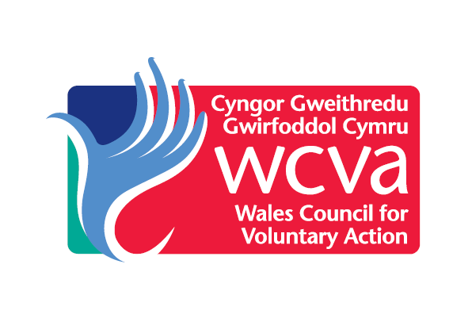

Person Specification
Cleaner / Relief Caretaker
KNOWLEDGE & EXPERIENCE | Essential / Desirable | How this will be assessed
Practical experience of cleaning to the highest standards | Essential | Application
A basic understanding of repairs / maintenance issues | Desirable | Application/ Interview
Experience of working in a customer focussed environment and a proven record of providing courteous and helpful service to colleagues / customers | Essential | Application/ Interview
Basic knowledge and experience of H&S principles (i.e. manual handling, Control of Substances Hazardous to Health, use of Personal Protective Equipment, Fire Awareness, Accident and Incident reporting) | Essential | Application/ Interview
Experience of working in a team | Essential | Application/ Certification
SKILLS AND ABILITIES
Self-motivated with the ability to use own initiative to prioritise daily workload. | Essential | In Tray Exercise / Interview
Ability to carry out tasks to the required standard without close supervision | Essential | Interview
A commitment to maintaining confidentiality at all times | Essential | Application / Interview
Ability to undertake a range of manual cleaning activities (i.e. sweeping, hovering, moping, polishing, cleaning low and high level units etc.) | Essential | Interview
Ability to work flexible hours on occasions (in order to fulfil the requirements of the Relief Caretaker role) | Essential | Interview
Ability to undertake training courses that are relevant to the duties of the post or are required for Health and Safety reasons. | Essential | Interview
Welsh Language Skills | Desirable | Application

Creating Enterprise are committed to Equality and Diversity in our activities

